

Mandatory Zip Code GL Location  
Enhancement Requirements.

**Policy Decisions**

**Version 1.0** ● September 13, 2021

# Document History & References

## Revision History

| Ver. | Rev. Date | Summary of Changes | Author |
| --- | --- | --- | --- |
| 1.0 | 07/07/2021 | Initial Draft | Dhanraj Kotian |
|  |  |  |  |
|  |  |  |  |
|  |  |  |  |
|  |  |  |  |
|  |  |  |  |
|  |  |  |  |

## Review and/or Approvals

| **Version** | **Date** | **Stakeholder** | **Signature / Email Reference** |
| --- | --- | --- | --- |
|  |  |  |  |
|  |  |  |  |
|  |  |  |  |

## Team Contact List

| Name | Role | Telephone | Email |
| --- | --- | --- | --- |
| Dhanraj Kotian | BA | 860.616.7751 | [Dhanraj.Kotian@insurity.com](mailto:Dhanraj.Kotian@insurity.com) |
| Ellen Tinneberg | ARCH IT | |  |  |  | | --- | --- | --- | | |  | | --- | | 201.743.4249 | |  | | |
| Kristen Hammick | Dev Lead | 860.616.2628 | [Kristen.Hammick@insurity.com](mailto:Kristen.Hammick@insurity.com) |

## Reference Documents and/or Attachments

**Note:** Paper copies are valid only on the day they are printed. Contact the author if you are in any doubt about the accuracy of this document.

Please see the following documents for more information:

| Document Name | Version | Author |
| --- | --- | --- |
|  |  |  |

# Policy Decisions

## Business Purpose

|  |
| --- |
| As a user of Policy Decisions, I need the application to ensure I add all applicable information. The zip code field should not be allowed to be left blank on GL locations so please make this mandatory, so it is not overlooked.  Value added is that I have a complete address where my insured is located.  Accepted Criteria:  Create a GL (pkg and monoline) quote with one location and leave the zip code blank.  Verify that PDE won’t allow you to leave the screen without entering a valid zip. |

## Assumptions/Constraints/Dependencies/Out of Scope

|  |  |
| --- | --- |
|  | Mark this box with an “x” if this section is not applicable to the enhancement. |

|  |  |  |
| --- | --- | --- |
| ID | Assumption | Reference |
| AS01 | This change is only applicable when GL is on a package or monoline policy and the user is going through policy decisions screen flow. Any automated process, example APIs or location upload will not be supported. |  |
| AS02 | Except for UI no other downstream system update is requested. |  |

## Process

### Current Process

|  |  |
| --- | --- |
| ID | Description |
| CP01 | Currently when the user tries to “Add Location-Class Code” on the “General Liability Location-Class Code Information” screen the “Zip Code” on the “Add a Location” pop screen is optional. If the user does not enter a zip code or does not use City Help or Address Validation this field remains blank, and the user can issue the policy without a zip code on that GL location. This is causing errors in Arch’s WINS. |

### Proposed Process

|  |  |
| --- | --- |
| ID | Description |
| PP01 | For the scenario described in CP01, the “Zip Code” field on the “Add a Location” pop screen will be changed from optional to mandatory. |
| PP02 | In an event if there is still no zip code on a GL location (pkg or monoline), the user will NOT be allowed to issue the policy and an edit message will be displayed advising the user to go back to the GL locations in which the zip code is missing and complete the required zip code field. |

## Business Requirements

| **ID** | **Business Requirements** | **Reference** |
| --- | --- | --- |
| **Category 1** | **User Interface** |  |
| BR101 | When user tries to “Add Location-Class Code” on the “General Liability Location-Class Code Information” screen the “Zip Code” on the “Add a Location” pop screen shall be mandatory. |  |
| BR102 | In an event if there is still no zip code on a GL location (pkg or monoline), the user shall NOT be allowed to issue the policy and an edit message shall be displayed advising the user to go back to the GL locations in which the zip code is missing and complete the required zip code field. |  |

## Functional Requirements

### General Information

|  | **Topic/Requirement** |
| --- | --- |
| **Writing Companies** | |
| FR0001 | All |
| **States** | |
| FR0002 | All |
| **Line of Business** | |
| FR0003 | Only when GL is on a Package or Monoline policy |
| **Effective Date** | |
| FR0004 | 01/01/2022 |
| **User Types** – Agents/Brokers, Insureds/Consumers, Internal Users Only | |
| FR0005 | All |
| **Organizational Structure** – Are there any specific requirements to implement this change for a particular program, business unit, regional office or other customer-specific organizational structure? | |
| FR0006 | All |
| **Product/Area of Impact** – Policy, Billing, Claims, Reporting Decisions, DataHouse | |
| FR0007 | Policy Decisions Evolution |

### User Interface Changes

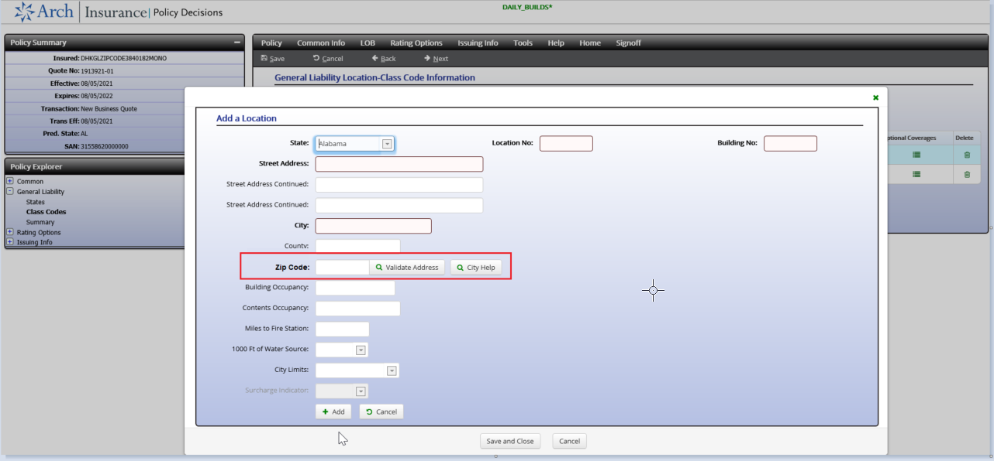

|  |  | | |
| --- | --- | --- | --- |
| FR0101 | **Screen** | Add a Location on the “General Liability Location-Class Code Information” screen | |
| **Field Name** | Zip Code | |
| **Database Field** (*Internal)* | *(To be completed by Dev)* | |
| **Tool Tip/Hover Help** | No Change | |
| **Enabled / Required (Y/N)** | Change this field from optional to required | |
| **Values** | **Display** | **Data** (*Internal)* |
| N/A |  |
| **Description:**  If Zip Code is missing on renewing policies on or after 01/01/2021, then the user will NOT be allowed to issue the policy and an edit message will be displayed advising the user to go back to the GL locations in which the zip code is missing and complete the required zip code field. Follow PDE standard messaging during issuance. | | |

### Rate Tables

Not Applicable

### Rating Formulas

|  | **Rating Formulas** |
| --- | --- |
| FR0301 | Not Applicable |

### Worksheets

|  | **Worksheet Changes** |
| --- | --- |
| FR0401 | No change but regression test to make sure zip code prints on rating worksheet and ISO statistical coding. |

### Forms (if no separate Forms Requirements Document)

|  | **Forms Changes** |
| --- | --- |
| FR0501 | Not Applicable |

### Change Narratives

|  | **Change Narrative** |
| --- | --- |
| FR0601 | Not Applicable |

### Underwriting

|  | **Underwriting Rule Change** |
| --- | --- |
| FR0701 | Not Applicable |

### Interfaces

|  | **Interface** | **Description of the Change** |
| --- | --- | --- |
| FR0801 | WINS | No change |
| FR0802 | ISO/AAIS/NCCI Statistical Coding | No change – regression test zip code is being reported. |
| FR0803 | Client-Specific Statistical Coding |  |

### Impact to Existing Policies

Will this modification use an SRV? Not but will be implemented using an effective date.

If an SRV will not be used, what is the impact to Existing Policies? Existing policies will be impacted when they renew post effective date of this enhancement. User will have to go and add the missing zip code on their GL policies.

If an SRV will not be used, what is the impact to Existing Quotes? Same as above.

### Impact to Other Systems

Does information identified in this requirement need to be passed to Billing Decisions? No

Does information identified in this requirement need to be passed to Claims Decisions? No

Does information identified in this requirement need to be passed to ACORD / DataHouse? No

### Other Requirements

|  | **Requirement** |
| --- | --- |
| FR0901 | Not Applicable |

## Testing Requirements

The Testing Requirements section lists the test cases this document contains. It also provides a summary of those test cases by describing them as a set of activities specific to a business scenario. These use cases will be very specific to your enhancement.

Please provide scenarios for testing in the table below.

| **Scenario** | **Description** | **Expected Result** | **Requirement Reference** |
| --- | --- | --- | --- |
| TS100 | Test GL on monoline and package, after effective date. | Field should be required. |  |
| TS101 | Test non-GL lob and package without GL | Field should be optional |  |
| TS102 | Make sure zip code prints on rating worksheet and ISO statistical coding. |  |  |

## Technical Considerations (*Internal use during development)*

### Configuration

### Reference Table Updates

### Database Fields

### Stored Procedures

### Pre and Post Rating Validation

### Exceptions to Standards Document

### Rating Formulas

***Calculation Information***

# Sign-Off

**Insurity**

The information contained within this document accurately reflects the requirements for the requested functionality and adhere to the requirements needs for the represented functional domains. These requirements formulate the baseline against which change is managed.

|  |  |  |
| --- | --- | --- |
|  |  |  |
| Signature of Reviewer |  | Date |
|  | | |
| Name/Position | | |

|  |  |  |
| --- | --- | --- |
|  |  |  |
| Signature of Reviewer |  | Date |
|  | | |
| Name/Position | | |

**Customer**

The information contained within this document accurately reflects the business requirements for the requested functionality.

|  |  |  |
| --- | --- | --- |
|  |  |  |
| Signature of Reviewer |  | Date |
|  | | |
| Name/Position | | |